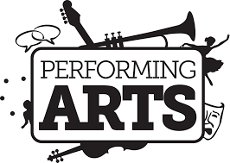 | Indian Hills High School Performing Arts Association
2019-2020
In This Issue  - Welcome  - Accomplishments  - Get involved!  2019 - 2020 PAA Board  Bonnie Algarin / Open  PAA Chair (Interim)  Open  Secretary  Tracey Campbell  Treasurer  Meeting Dates  Sept 18  Oct 16  Nov 13  Dec 18  Jan 15  Mar 18  Apr 15  May 13  All Meetings are in the  IHHS Library at 7:00 pm  Meeting dates are subject to change  Performing Arts: For individual webpages, please see the links on our webpage  Marching Band  Symphonic Band  Jazz Band  Wind Ensemble  Concert Choir  Chamber Choir  Dance Team  Drama Club  Orchestra  NJ Concert Band  Contact Us  Fundraising: IHHSPAA@GMAIL.COM  General: IHHSPERFORMINGARTS ASSOCIATION@GMAIL.COM | Welcome!  We would like to invite you to join the Performing Arts Association (PAA) at Indian Hills High School. The PAA is comprised of dedicated parents that support the Performing Arts at Indian Hills High School (IHHS).  If you have a student in the symphonic band, marching band, wind ensemble, orchestra, jazz band, choir, drama, or dance or are active in school productions in any technical fashion, then we are the organization for you!  Accomplishments  Through membership fees, fundraising and patron support the Performing Arts Association:  - Provides scholarships for performing seniors whose parents belong to the PAA (4 year membership required);  - Donate gifts to the school to enhance and supplement performing arts programs such as music stands for the band, wireless microphones for stage shows and paid advertising in show programs;  - Provide financial support for departmental expenses not otherwise covered by the BOE such as accompanists for performances, help defray costs for the annual music department trip;  - Support the Teen Arts Festival as a venue for students to put on their own show, raise money for charity and perform community service;  - Sponsor the North Jersey Concert Band concert to show students that music does not end at graduation;  - Promotes awareness of Performing Arts programs and events throughout the school and within the FLOW communities.  Get Involved!  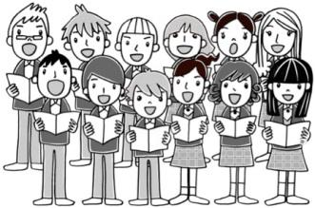 Because of the vibrant arts environment and outstanding parent, student, teacher and administrative support at IHHS, the PAA can help create a ripple effect that will positively impact our students’ lives. We represent YOUR concerns to the Board of Education. We recognize that our strength as an organization stands with the size of our membership and that is why we became an active committee of the PTSO.  Joining the PAA is as easy as going to www.RIH.org; clicking on Parent Org tab; Click Here for the PTSO’s website; go to My Account tab; Create a new Indian Hills PTSO account and select PAA membership. The membership fee covers your membership to the PAA for the year. 4 year membership is required to be eligible for a PAA scholarship your child’s senior year!  We sincerely hope that you take this opportunity to join us so we can help make this a terrific year for all the students who participate in the Performing Arts. Through your support and guidance, we offer students a more rewarding experience in the Performing Arts, which, in turn, will lead them to inspire others!  Please join us on for our first meeting of the year ~ we would love to see you!  You can also help support the PAA by purchasing a ShopRite Savings Card ~ information is on our website on how to purchase one!

